Start your Research

About this Guide
This guide is designed to help you find print and electronic resources for researching a variety of careers and jobs! CMU Libraries, in tandem with the CMU Career & Professional Development Center (CPDC) have collected many books and resources on these topics to help YOU during your job/career exploration! Check out the various tabs on this guide that contain resources for:
Finding an Employer
Interviewing and Networking
Graduate Education Resources
Book Recommendations by Topic

Career books
There are hundreds of books and e-books on interviewing, career exploration, networking, resumes, etc. for every kind of occupation. Find them in the library catalog - try using:
- job hunting
- vocational guidance
Also check out additional titles on the Book Recommendations tab!
With a keyword from your chosen field. Some examples:
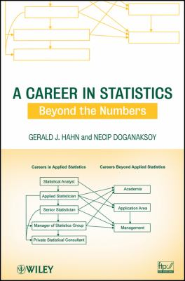
A Career in Statistics (eBook) by J. Mather; Necip Doganaksoy; Gerald J. Hahn

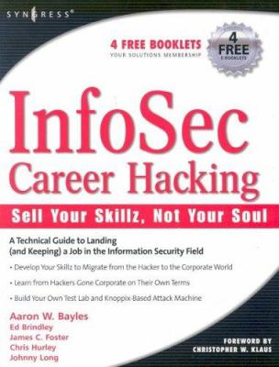
InfoSec Career Hacking (eBook) by Aaron W. Bayles; Chris Hurley; Johnny Long; James C. Foster; Christopher W. Klaus (Foreword by); Ed Brindley


Becoming a Mathematician (eBook) by Leigh N. Wood; Peter Petocz; Anna Reid


Career Planning for Research Bioscientists (e-book) by Sarah Blackford

Some Basics
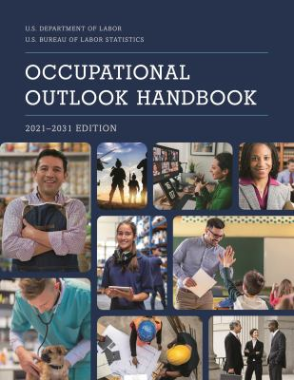
Occupational Outlook Handbook by Bureau of Labor Statistics (Editor)
Publication Date: 2023

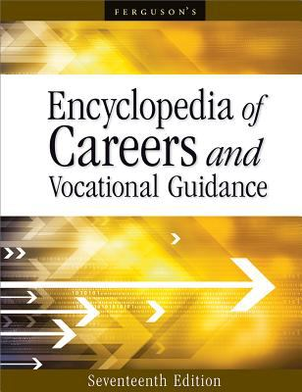
Encyclopedia of Careers and Vocational Guidance by Ferguson Publishing Staff (Contribution by)

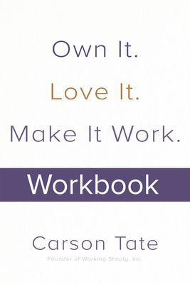
I Got My Dream Job and So Can You: 7 Steps to Creating Your Ideal Career After College by Pete Leibman
Publication Date: 2021


What Color Is Your Parachute 2015 : A Practical Manual for Job-hunters and Career-changers by Richard N. Bolles
Publication Date: 2022

Find an employer

Company listings
Hoover's (Now D&B Hoovers) Use "build a list", or, find a company you are interested in, then check “competitors” on left hand side. Is international. No downloading, but has company profiles.
ReferenceUSA (now Data Axle) Various modules: US and Canadian companies of all sizes, consumer data, job postings, healthcare offices, personal listings, new business filings, with data visualization and mapping applications. For in depth research: the OneSource module has extensive corporate information on over 5 million global firms.
PrivCo US private company financials, information on private M&A deals, valuations, venture capital, private equity, etc. Over 800,000 US private companies profiled. Good for locating investors and competitive intelligence. NOTE: You must create an account using your CMU email. Use of this database is for academic purposes only.
CB Insights
A comprehensive global database of private companies and investors activities. Contains advanced searches for private companies, investors, and deals information (especially private equity and venture capital). Also great for news on emerging markets. An excellent resource for startups and entrepreneurship research. (NOTE: You must create an account using your CMU email).

Salary and relocation information
Salary.com
Climbtheladder
Glassdoor

Job listings
There are hundreds, but these seem to be the most recommended:
CMU Handshake
Handshake is CMU's online recruiting platform that will allow you to explore, find, and apply to job and internship opportunities, connect with great companies, and learn about your career options.
Pittsburgh & PA Jobs and Internships (CPDC)
If you are looking for jobs or internships in the local area, check out these resources from the CPDC!
Indeed
comprehensive international job search site; also gives salary and employment trend data.
USAjobs.gov
thousands of jobs from the US government's official site for federal employment, in every field
Internships.com
Large internship marketplace, including paid and unpaid, full and part-time internships in the US.
ZipRecruiter
comprehensive international job search site; also gives salary data.

Academic job listings
Jobs advertised in the Chronicle of Higher Education
H-Net Job Guide
announcements in the Humanities and the Social Sciences
Jobs for Historians
Scientist jobs
from the American Association for the Advancement of Science

Nonprofits
Hoover's (Now D&B Hoovers) This link opens in a new window
Same as the one under "Company listings" - contains nonprofit organizations of all kinds.
Leadership Connect (formerly Leadership Library) This link opens in a new window
primarily US but also some international - major organizations of all kinds with extensive contact information and quick profiles.
Guidestar.org
Full information, including financials, on all nonprofits in the US. To get full advantage, register first (it's free). Use "Advanced Search" for best results.
Idealist
Nonprofit organizations.

Universities and Research Centers
Research Centers Directory
Peterson's Test Prep
Current study guides and practice tests for graduate school exams - MCAT, GMAT, LSAT, GRE - and the TOEFL, as well as a graduate school search feature. Individual users must create an account to access content.

Interviewing/Networking

Interview Prep - Get Employer Background
Hoover's (Now D&B Hoovers) U.S. and international companies and nonprofits; brief description, leadership, history, financials, products, etc.
MarketLine (previously Datamonitor) find your company, and then see the sections on the left – particularly the SWOT analysis.
Glassdoor.com
based on millions of user reports, covers specific companies: salaries, interviewing experiences, what it's like to work there. Information is crowd-sourced, not checked, however.
More in our company research guide

CPDC Interviewing & Networking Resources
Big Interview
A digital platform that CMU students can use to learn and practice interview skills. With Big Interview you can get hands-on training with mock interviews that are tailored to your specific industry, job, and experience level.
CMUniverse
CMUniverse is a virtual mentoring platform that lets students choose how and when they want to engage with alumni.
CMU Alumni LinkedIn Group
This group is for Carnegie Mellon alumni, current students, faculty and staff to network, share jobs opportunities, start new business ventures or just get back in touch.

Interview Prep - Review an Industry or Field
IBISWorld This link opens in a new window
Industry market research reports with analysis, data, conditions, segmentation, market share, primary companies, and outlook.
Frost & Sullivan This link opens in a new window
Market reports and analysis on technology aspects of industries. Industries include: aerospace & defense, automotive, chemicals, consumer products, electronics, healthcare, and more. Reports are now available to download as PDFs.
Use of this resource is only for academic research purposes .
More in our industry research guide

Networking - Discover Someone's Background or Locate Contacts
Leadership Connect (formerly Leadership Library) This link opens in a new window
important people in companies, nonprofits, governments, media, law, etc. Includes email, phone, bios.
Pivot
researchers and experts from universities, government agencies, and R&D organizations internationally
Networking through professional associations: every job has an association that supports it, both nationally and locally; find yours. Most have student memberships. Don't forget to look at their job boards!
- Try googling key words (i.e. "finance association pittsburgh" will turn up the Pittsburgh Association for Financial Professionals.)

Books on interviewing
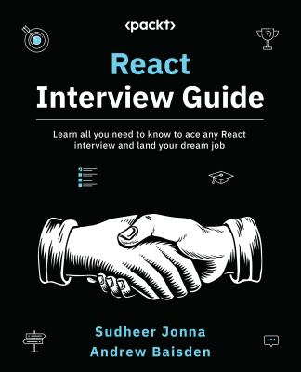
React Interview Guide by Sudheer Jonna; Andrew Baisden
Publication Date: 2023


Acing the System Design Interview by Zhiyong Tan
Publication Date: 2024

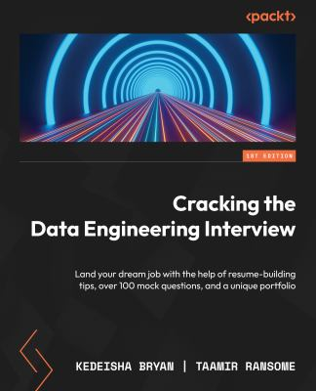
Cracking the Data Engineering Interview by Kedeisha Bryan; Taamir Ransome
Publication Date: 2023

Graduate education

Graduate school exploration

Is Graduate School Really for You? by Amanda I. Seligman

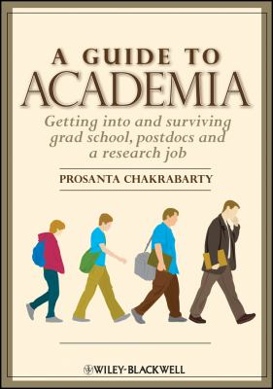
A Guide to Academia by Prosanta Chakrabarty

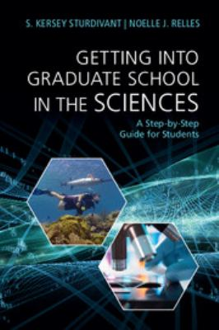
Getting into Graduate School in the Sciences by S. Kersey Sturdivant; Noelle J. Relles

TEST books, practice tests and graduate school info.
Peterson's Test Prep
Current study guides and practice tests for graduate school exams - MCAT, GMAT, LSAT, GRE - and the TOEFL, as well as a graduate school search feature. Individual users must create an account to access content.

PhD job exploration
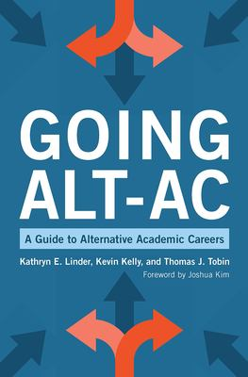
Going Alt-Ac: A Guide to Alternative Academic Careers by Kathryn E. Linder; Kevin Kelly; Thomas J. Tobin
Publication Date: 2020

Recommended Books!

Explore Career Books by Topic/Area!
CMU Libraries and the CMU Career and Professional Development Center (CPDC) have worked to provide new and updated Career-related books that are available for all CMU faculty, staff, and students! Some books are available in print and others are available electronically.
Below is a sampling of some of the new titles we have added by different topic areas of interest. PLEASE CHECK THEM OUT!

Career Exploration
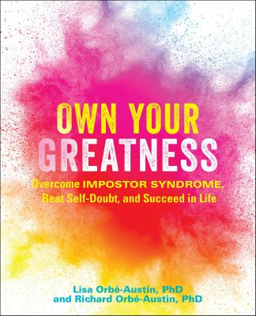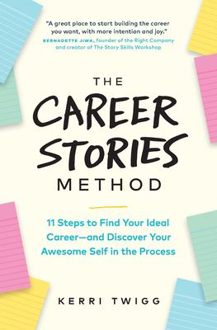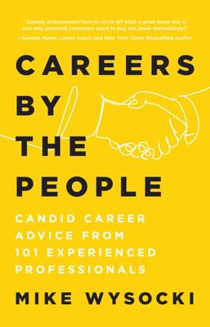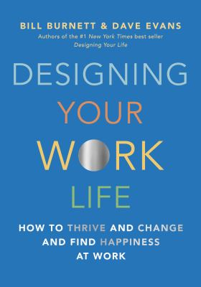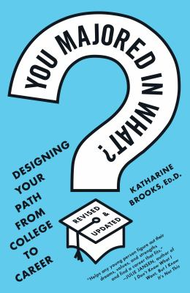

Public Speaking & Communication
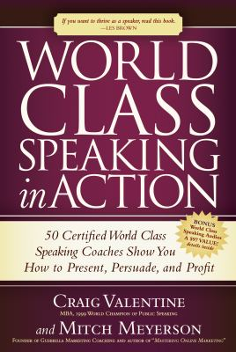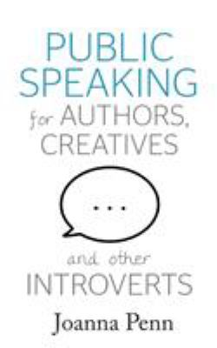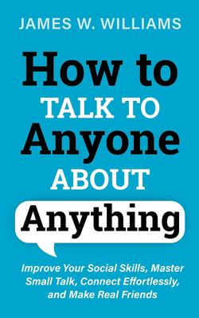

Management & Leadership
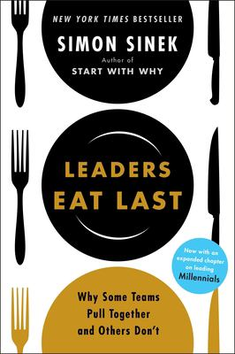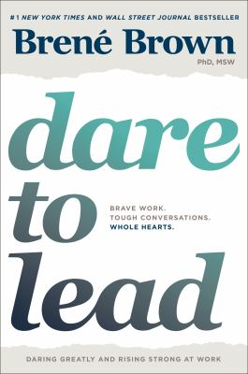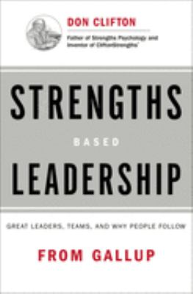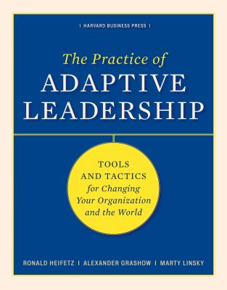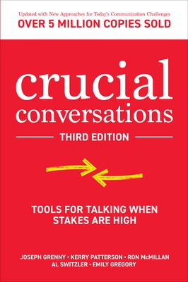

DEI
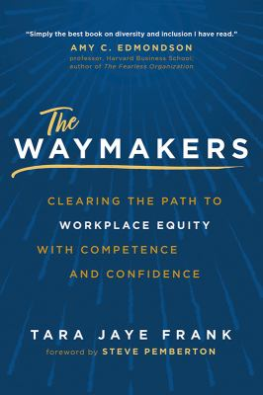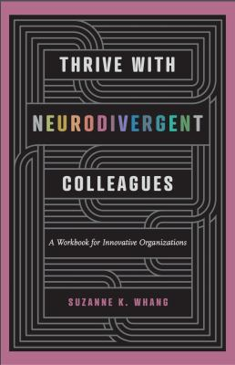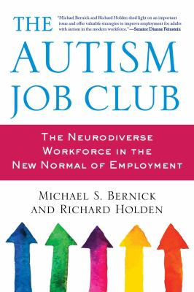

Interviewing & Networking
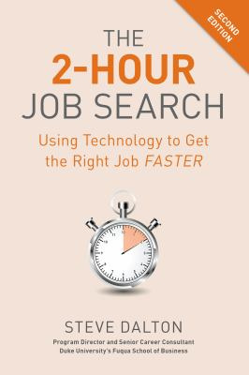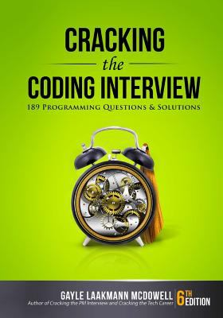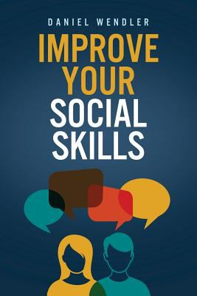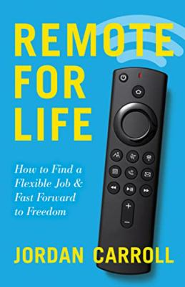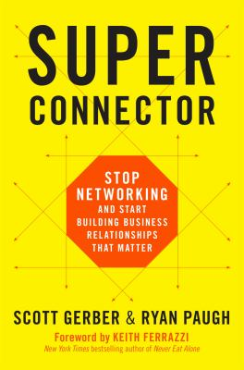

Ask for help

Frequently Asked Questions
Consult our FAQ for answers to frequent questions about the Libraries, our locations, and our resources.
Search
0 options available. Use up and down arrows to browse available options and enter to select one.
SHow can I return my library books when the library is closed?
Can I borrow a video camera and other multimedia equipment?
Can I eat or drink in the library?

Schedule a Consultation
Find your departmental librarian or other people who work in the University Libraries.
Not sure who to meet with?? Submit a ticket.
Get help with coding and data science projects on the Data and Code Support page. Click the link and scroll to the bottom of the page to schedule a consultation with our team.

Career & Professional Development Center!
The Career and Professional Development Center (CPDC) is Carnegie Mellon University’s centralized career services center. We provide a comprehensive range of services, programs, and materials focusing on career exploration, professional development, experiential learning and employment assistance to meet today’s evolving workplace and student goals of finding satisfying work!

